 | UK Chinese Music  London Youlan Qin Society  Saturday Chinese Music Classes  18th January – 5th April 2025  (Except 1st Feb and 7th March)  Registration form |  | 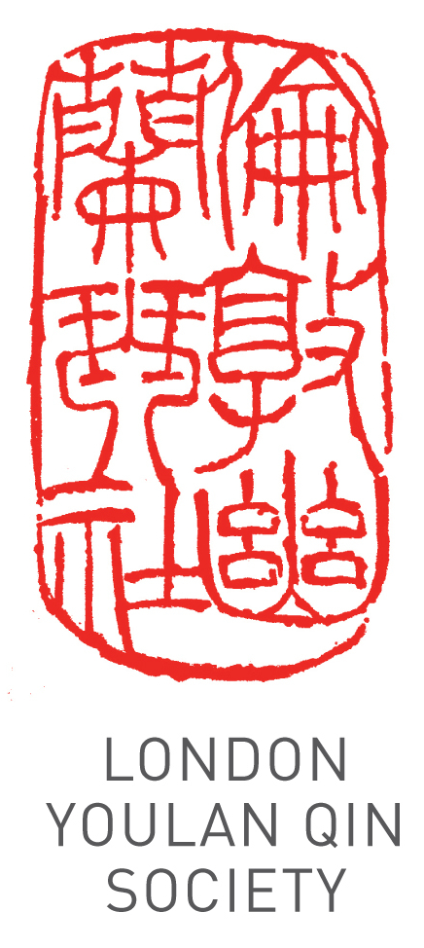
Applicant Details
Title (Dr/Mr/Ms/other):
Name:
Address:
Phone: Email:
Registration Information
Which instrument(s) do you wish to learn? |  | ..................
Do you already play the instrument? |  | Yes |  | No
If so, to what level? | Beginner | Intermediate |  | Advanced
Attendees are strongly encouraged to use their own instrument. A limited number of instruments are
available for hire and for purchase. Please tick the box if you need to hire an instrument

Payment
10 weekly in-person instrumental group lessons £300
10 weekly in-person ensemble classes £220 (free if taking one of the above courses):
Individual 1-to-1 lessons: £50/hour
Specify Course(s): …………………… 10% discount for SOAS students/LYQS/members: …………
Total £ …….
Bank: HSBC
Account name: China Arts Ltd
Account number: 11440691
Sort Code: 40-20-07
IBAN: GB89HBUK40200711440691
BIC: HBUKGB4129V
Please pay by bank transfer, specifying your name as reference, and email a scan of the transaction. Please make your payment at least two days before your first lesson.
I wish to register for the course.

Signature: ____________________________ Date: ______________________
Please email the completed form and proof of payment (e.g. screen capture of the transaction) to info@ukchinesemusic.com.

Please note that the course fee cannot be refunded if the attendee misses any classes.

